

*Created by-* [*Hamza Mughal*](https://github.com/hamza-mughal1)

*“Where Rhythm Meets Challenge!”*

**Music Tiles**

# **Overview:**

Music Tiles is a tile-based rhythm game inspired by the mobile game "Piano Tiles". It challenges players to hit corresponding buttons in time with falling tiles to the beat of the music. Developed using Python's Pygame library, Music Tiles offers an engaging and rhythmic gameplay experience.

# **Key Features:**

## **Tile Generation:**

Falling tiles represent musical notes, and players must press corresponding buttons to hit these notes.

## **Multiple Music Tracks:**

Players can choose from a selection of music tracks, each offering a unique gameplay experience.

## **Score Tracking:**

The game keeps track of the player's score, rewarding accurate button presses and penalizing misses.

## **Speed Increase:**

As players progress, the game gradually increases in speed, intensifying the challenge.

## **High Score:**

Players can aim to beat their previous high score, providing replay value and a sense of achievement.

# **Main Logic Overview:**

The main logic behind the game is that, there will be 4 columns or platforms for tiles where tiles will be generated, and the tiles will come down according to the speed. And player will have 4 buttons on the screen representing buttons on his keyboard, so when player will press those buttons at the time when tiles are under those buttons then the score will increase. Or if player presses the button at the time when tile is not present under the button then the game will over and player will see end menu screen where he will see his score and high score with restart button. The game will increase the speed of tiles falling down as player gets more and more score, so it will create a challenge or difficulty for player to be engaged.

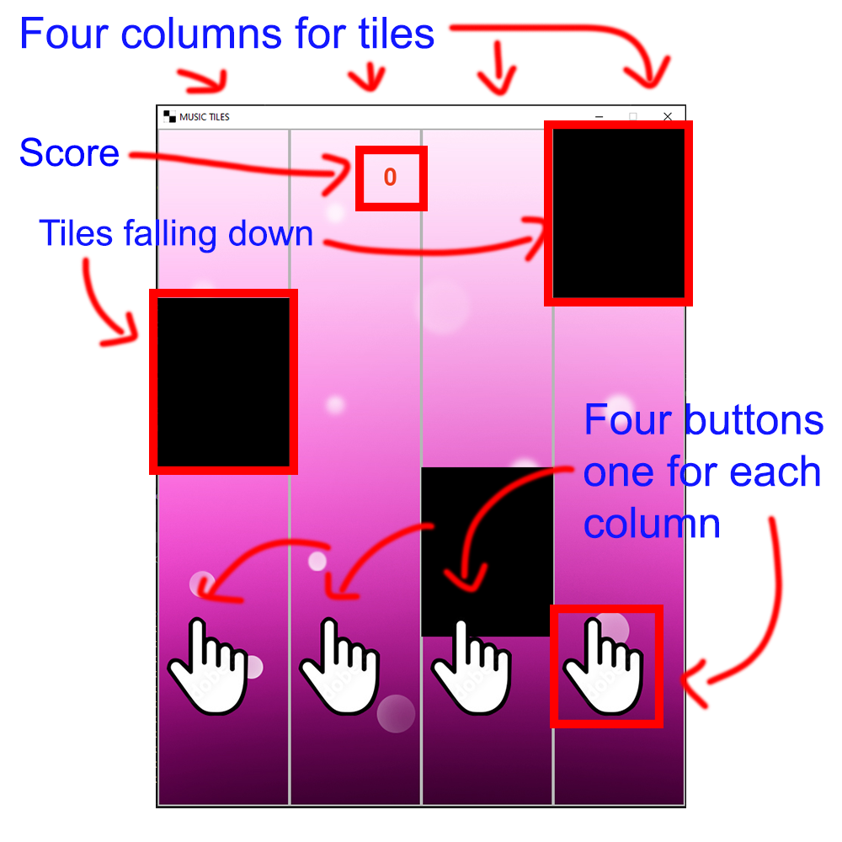

# **Main Menu Overview:**

The main menu gives player choice to choose from different music, when the player hovers the mouse over different music buttons then the button interacts and changes the color to white. And when the player presses the music button by mouse then the corresponding music starts playing and main menu screen changes into game screen. The main menu also contains controls guide which player can look at.

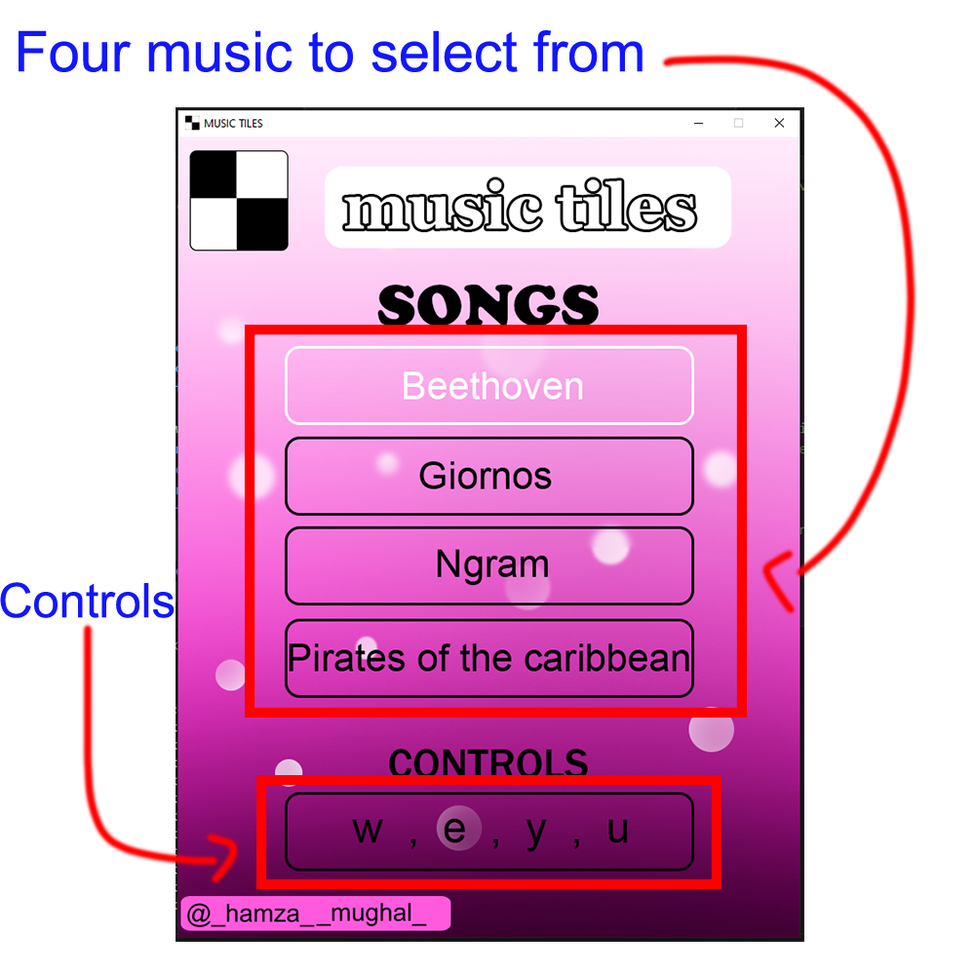

# **Tiles Generation:**

Tile generation logic works something like this, first it checks if any tile is on the screen means if not then the game is just started so it generates the tile, or if it is then it checks if last tile is at ‘y’ coordinate ‘0’ means there is room for another tile, so it generates the tile at ‘y’ coordinate ‘-255’ so when the tile comes down it doesn’t look bad and create smooth transition or illusion. Then it checks if the last tile is not in the same column as the tile it is about to generate, so the tiles doesn’t look bad, and if the tile is not on the same column, then it generates the tile or if it is on the column then it chooses again randomly other column.

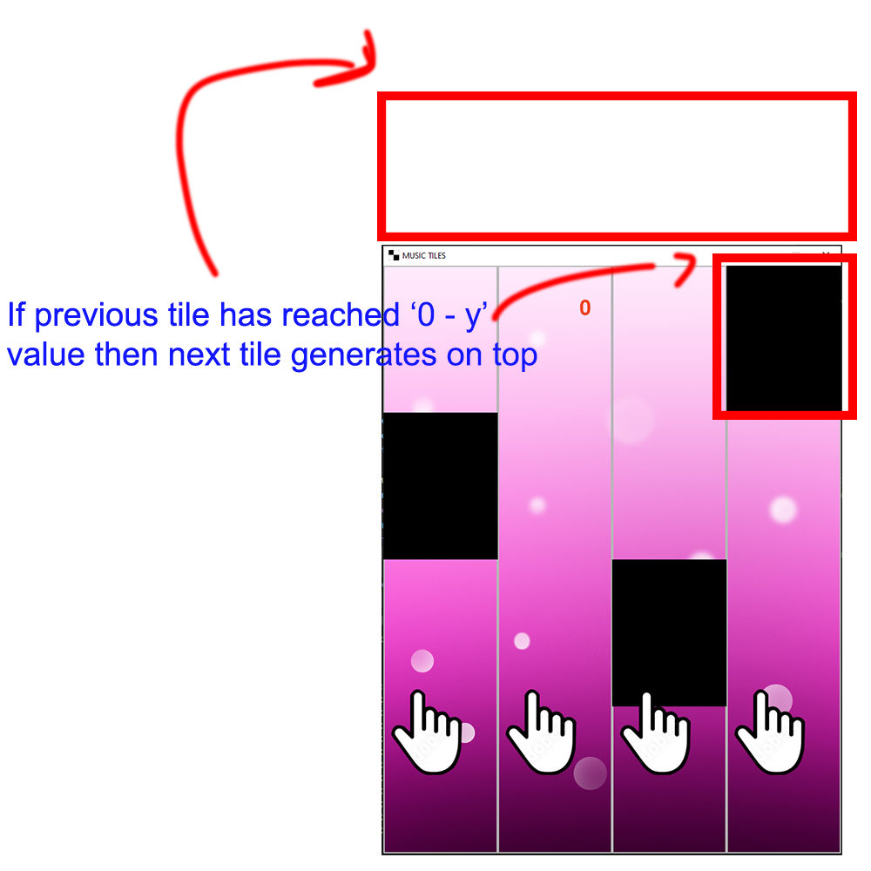

# **Game Ending Logic:**

The game checks if the player has pressed the button when tile wasn’t present there, or if tile reached to the button, means player missed the tile. And if any of the case is True then the game ended and player transfers to the end menu. Game checks all these collisions by creating two rectangles, one on the coordinates of button, and one on the coordinates of the tile. Then it checks for collision of both rectangles.

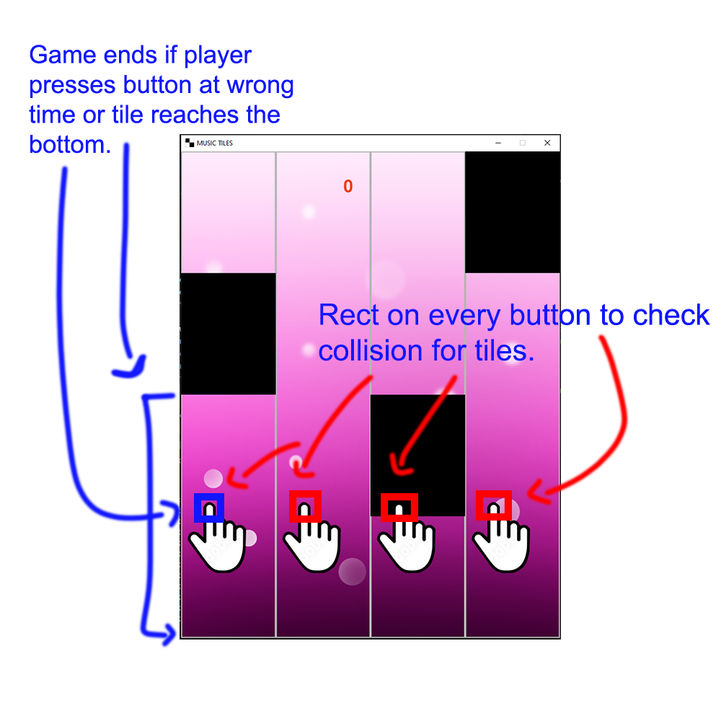

# **Score Management:**

First game checks if the file exists of high score, in case if someone has deleted it then game creates new file and sets the high score ‘0’, or if the file exists then game check for high score and read that high score into game and shows it into game. Game checks after every round if current score is greater than high score, then game sets high score to whatever new high score is. And at the end when player quits the game, then before closing the game check if there is new high score, if there is, then game changes the high score into the file. The score increases whenever the player hits the tile at right time, and also deletes the tile from the list containing all tiles in attribute of object of Tile class.

# **Speed Increment:**

The speed increment logic is very simple. The game check for the score if the score is divisible by ‘40’ remainder is ‘0, then game increases the FPS (frames per second) of the game. Which creates and illusion and looks like that whole game’s speed is increased. Because when there are more FPS in the game means the whole game will run faster, means the number of iterations per second will increases.

# **End Menu:**

End menu consist of three things.

* High score.
* Current score.
* Restart button.

The high score bar shows the high score of the player. The current score bar shows the score which was made by player in last round. And restart button allows player to play the game again, by pressing the restart button the game starts again.

# **Installation Instructions:**

* Ensure Python (3.8+) and Pygame are installed on your system.
* Download the game files and extract them to a folder.
* Run the game by executing the Python script: python music_tiles.py.

# **Credits:**

**The whole game was developed by:** Hamza Mughal.

**All visuals and UI was designed by:** Hamza Mughal.

**Music was collected from different platforms.**

**Project was made for:** Bano qabil 2.0

# **License:**

This game is provided under an open-source license, allowing for modification and redistribution. See the accompanying license file for details.

*Enjoy the rhythmic journey of Music Tiles and aim for the high score!*